Project Case | 
COMP6144
Web Programming
Computer Science | O202-COMP6144-SV03-00
Valid on Odd Semester Year 2019/2020 | Revision 00

- Seluruh kelompok tidak diperkenankan untuk:
The whole group is not allowed to:
    - Melihat sebagian atau seluruh proyek kelompok lain,
Seeing a part or the whole project from other groups
    - Menyadur sebagian maupun seluruh proyek dari buku,
Adapted a part or the whole project from the book
    - Mendownload sebagian maupun seluruh proyek dari internet,
Downloading a part or the whole project from the internet,
    - Mengerjakan soal yang tidak sesuai dengan tema yang ada di soal proyek,
Working with another theme which is not in accordance with the existing theme in the matter of the project,
    - Melakukan tindakan kecurangan lainnya,
Committing other dishonest actions,
    - Secara sengaja maupun tidak sengaja melakukan segala tindakan kelalaian yang menyebabkan hasil karyanya berhasil dicontek oleh orang lain / kelompok lain.
Accidentally or intentionally conduct any failure action that cause the results of the project was copied by someone else / other groups.

- Jika kelompok terbukti melakukan tindakan seperti yang dijelaskan butir 1 di atas, maka nilai kelompok yang melakukan kecurangan (menyontek maupun dicontek) akan di – NOL – kan.
If the group is proved to the actions described in point 1 above, the score of the group which committed dishonest acts (cheating or being cheated) will be “Zero”

- Perhatikan jadwal pengumpulan proyek, segala jenis pengumpulan proyek di luar jadwal tidak dilayani.
Pay attention to the submission schedule for the project, all kinds of submission outside the project schedule will not be accepted

- Jangan lupa untuk melihat kriteria penilaian proyek yang ditempel di papan pengumuman, atau tanya asisten anda.
Don’t forget to look at the project assessment criteria that posted on the announcement board, or ask your teaching assistant.

- Persentase penilaiaan untuk matakuliah ini adalah sebagai berikut:
Marking percentage for this subject is described as follows:

Tugas Mandiri  Assignment | Proyek  Project | UAP  Final Exam
- | 100% | -

- Software yang digunakan pada matakuliah ini adalah sebagai berikut:
Software will be used in this subject are described as follows:

Software
Software
PHP Composer
PHP Storm 2019.1
Laravel Framework 5.8
XAMPP 3.23 (Apache, PHP >= 7, MySQL)
Firefox / Chrome

Ekstensi file yang harus disertakan dalam pengumpulan tugas mandiri dan proyek untuk matakuliah ini adalah sebagai berikut:
File extensions should be included in assignment and project collection for this subject are described as follows:

Tugas Mandiri  Assignment | Proyek  Project
- | Folder Project (PHP, SQL, Image Files (JPG / PNG), ENV, HTML, CSS, SCSS, JS, JSON, HTACCESS, ARTISAN)

Soal
Case

General Provisions:
- Use MySQL as database and Laravel Migration features
- All file upload feature such as image and document must be stored to server storage
- Use PHP Framework Laravel 5.8 to build the project
- Use Laravel MVC concept (Model, View, Controller) to build the project
- Use Eloquent Query / Query Builder to work with database
- You are free to design your own database table based on given requirements
- Print screen given below is only an example. You are free to create your own user interfaces
- It is prohibited to install any kind of Laravel packages. You must use fresh installation of Laravel 5.8
- Only validation in the backend (using Laravel) will be graded

Bjora
Bjora is famous announcer company in Indonesia. To have a better engagement with their customers, Bjora company wants to create a website for their QnA (question-and-answer) website. In that website, user could find any information discussed by the community.
As a web developer, you are asked to create a website using Laravel 5.8 for this question thread. There are three types of user’s role in this website: Admin, Member, and Guest (non-logged-in user). For each role, the website must contain at least these pages:
    - Admin
- Home
- Answer
- Profile
- Inbox
- Master User
- Master Question
- Master Topic

    - Member
- Home
- Answer
- Profile
- Inbox
- My Question
    - Guest
- Login
- Register
- Home
Each page shows greeting to user and current date time. The descriptions for each page are:

Login
This page is accessible only to guest. This page allows user to log in to the website. Display an error message on the login page if user enters wrong combination of Email and Password.
If user has entered correct Email and Password, redirect user to the Home Page based on the user’s role. If user checks the “Remember Me” checkbox, the website will save the Email and Password using cookies.
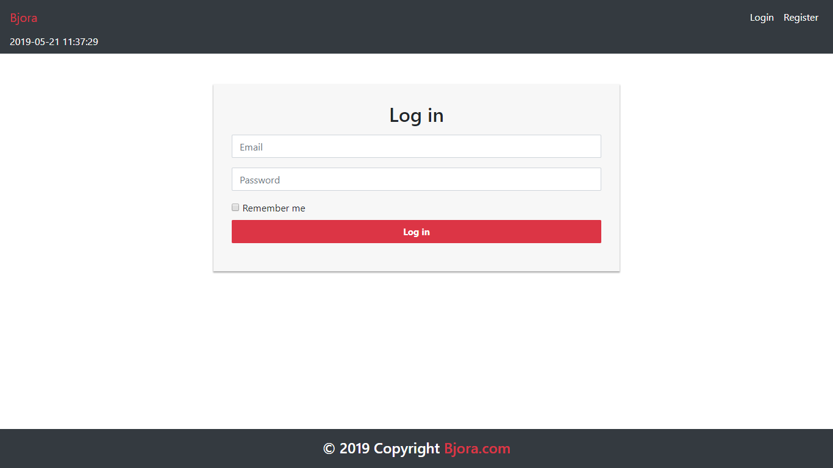
Figure 1. Login Page

Register
This page is accessible only to guest. This page allows guests to register themselves as a Bjora member. Display an error message if user input incorrect personal data.
The following table shows the existing fields on this page and the validation for each field:
Field | Information
Username | Must be filled with at most 100 characters
Email | Must be filled with email and unique
Password | Must be filled with at least 6 characters and alphanumeric format
Confirm Password | Must be filled and same with password
Gender | Must be selected
Address | Must be filled
Profile Picture | Must be selected and must match one of the allowed MIME types (jpeg, png, jpg)
Birthday | Must be filled with date format

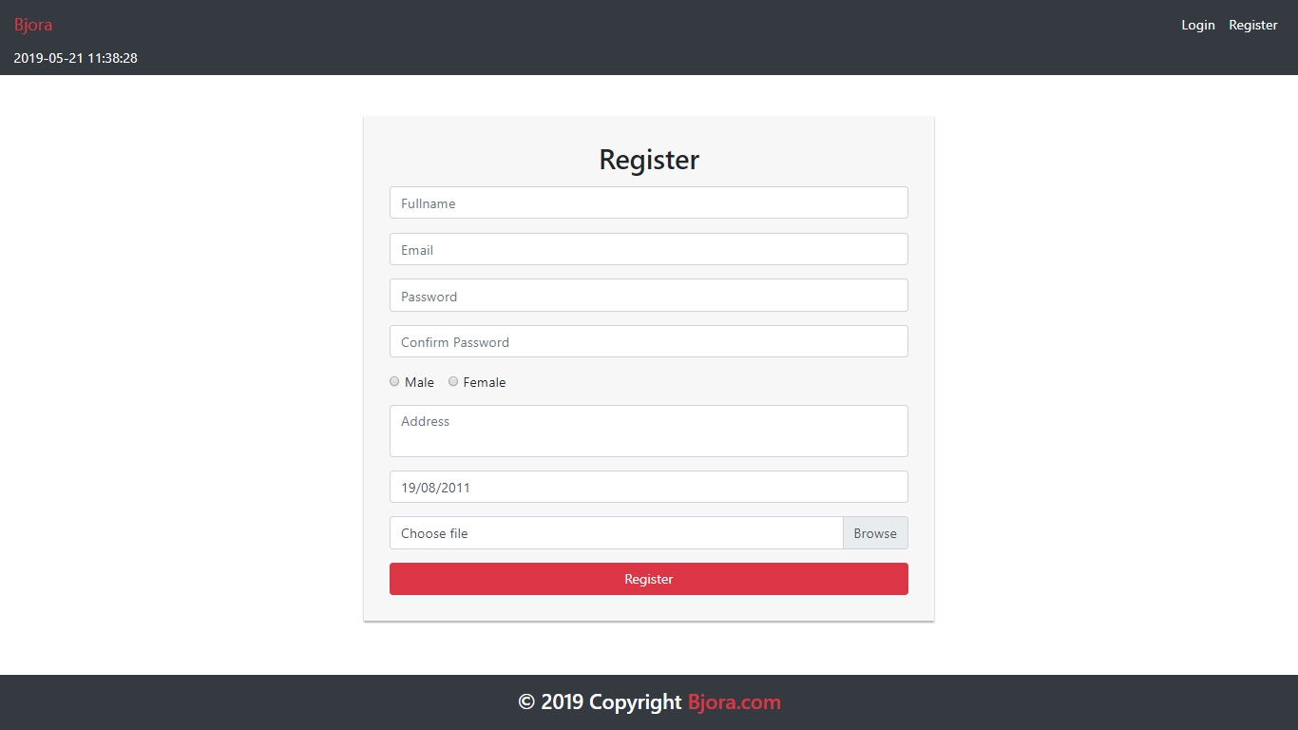
Figure 2. Register Page

Home
This page is accessible to all users. This page allows user to see all Bjora thread discussed by the community. This page allows user to search thread by either question or username. Bjora question is displayed using pagination with 10 questions for each page.
In navigation bar, there is an Add Question button. The Add Question button is visible if the user has logged in. If user clicks Add Question button, then the user will be redirected to Add Question Page.
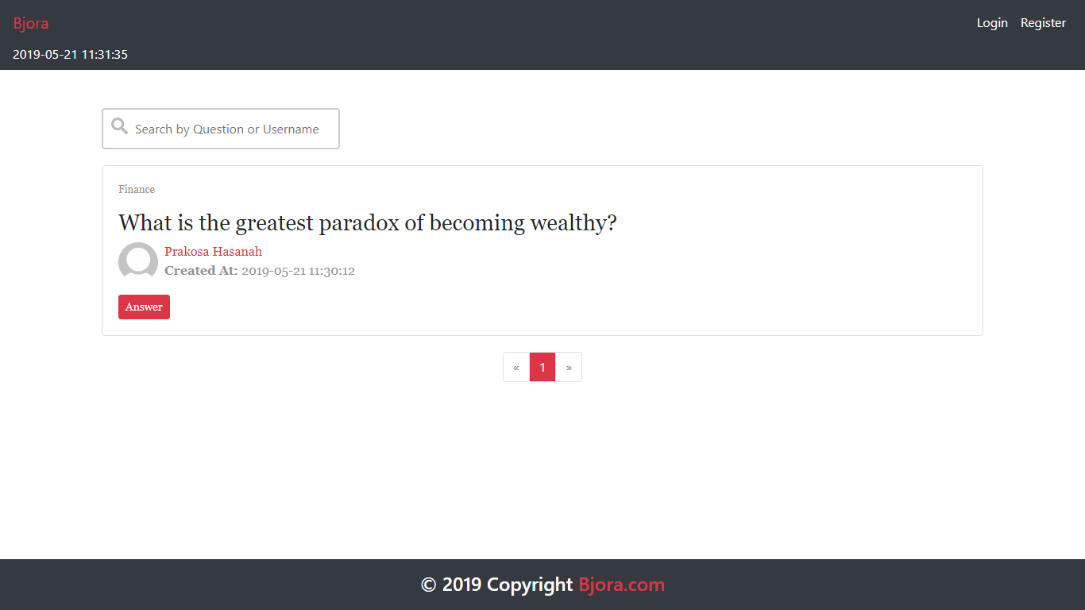
Figure 3. Home Page (for Guest)
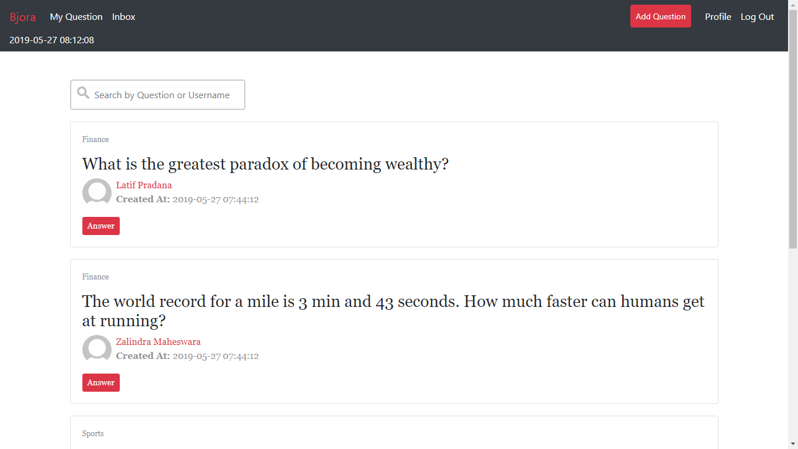
Figure 4. Home Page (for Member and Admin)

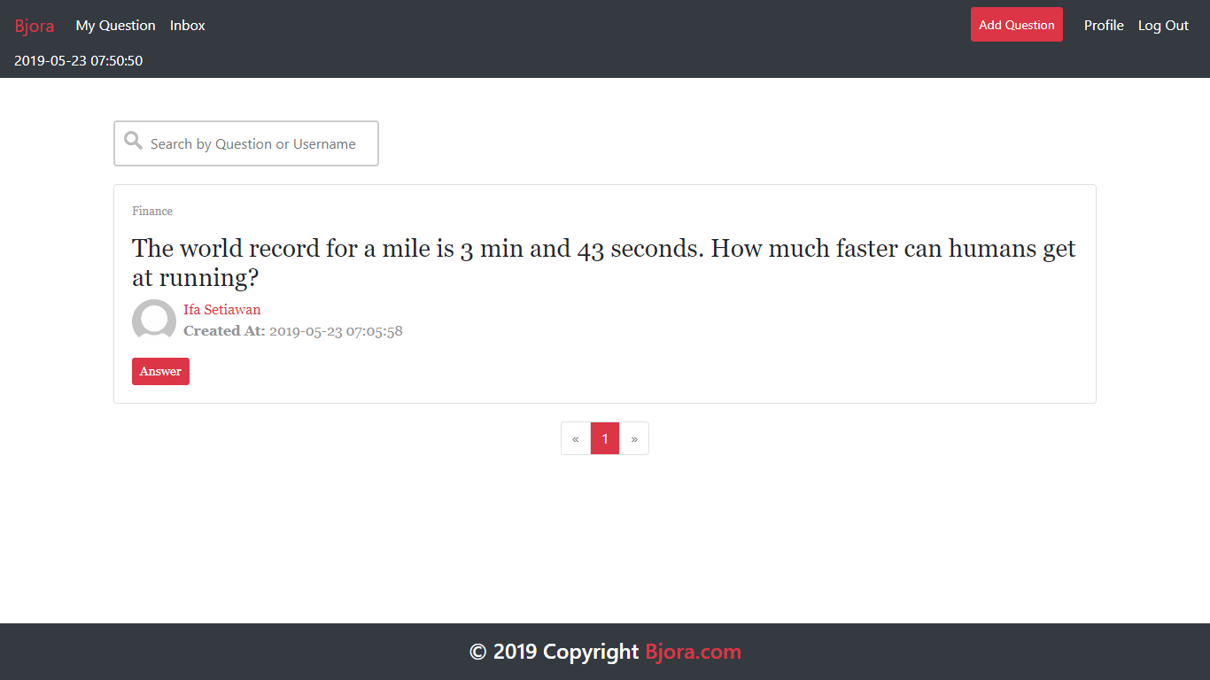
Figure 5. Searching Question with 'How' Keyword

Add Question Page
This page is accessible for member and admin. This page allows user to insert new question. Display error message if user input incorrect question data. The following table shows existing fields in the Add Question Page and the validation for each field:

Field | Information
Question | Must be filled
Topic | Must be selected

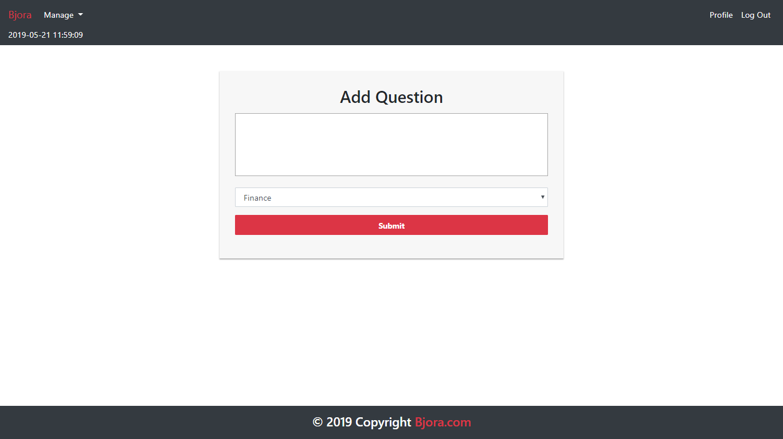
Figure 6. Add Question Page

Update Question Page
This page is accessible to member and admin. This page allows user to update their own question. Display error message if user input incorrect question data. The following table shows existing fields in the Update Question Page and the validation for each field:

Field | Information
Question | Must be filled
Topic | Must be selected

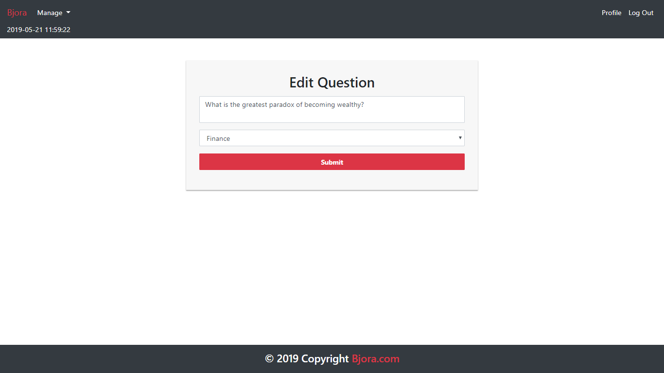
Figure 7. Update Question Page

Answer Page
This page is accessible to all users. This page can be accessed if user clicks Answer button in Home page. This page allows user to view and answer the selected question. Display question information such as question’s status (open or closed), question’s owner, question’s creation date, answer, answer’s owner, and answer’s creation date. Make sure all question’s owner and answer’s owner name can be clicked. Redirect user to profile page if user clicked the user’s name.
User could post an answer to the current question by using the form below the question. Show the form only to member and admin. The requirements for each field are:
Field | Information
Answer | Must be filled

The user can also update or remove their own answer. Validate that the update and delete buttons only appeared to the current logged in user’s answer. If user clicked the update button, redirect user to Update Answer Page. If user clicked the delete button, then delete the selected answer.
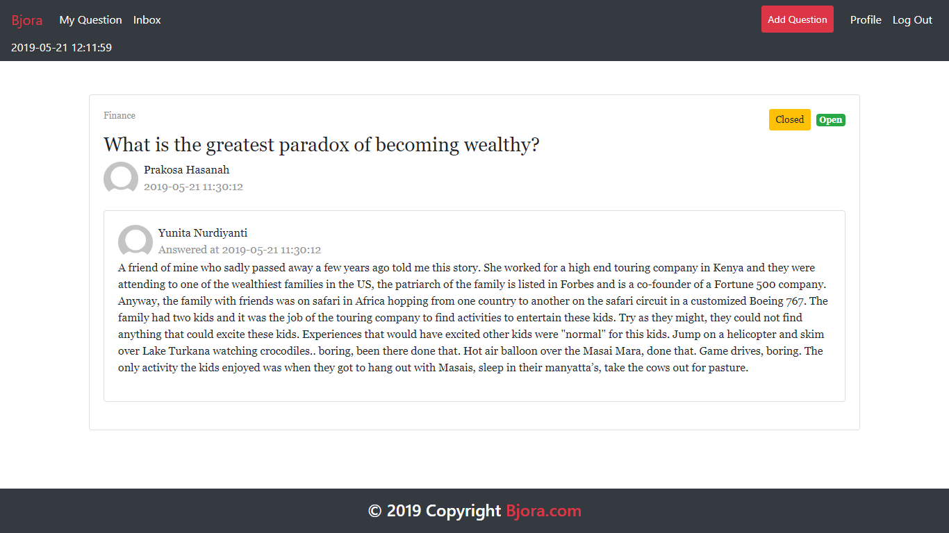
Figure 8. Answer Page (Opening Current Logged in User)

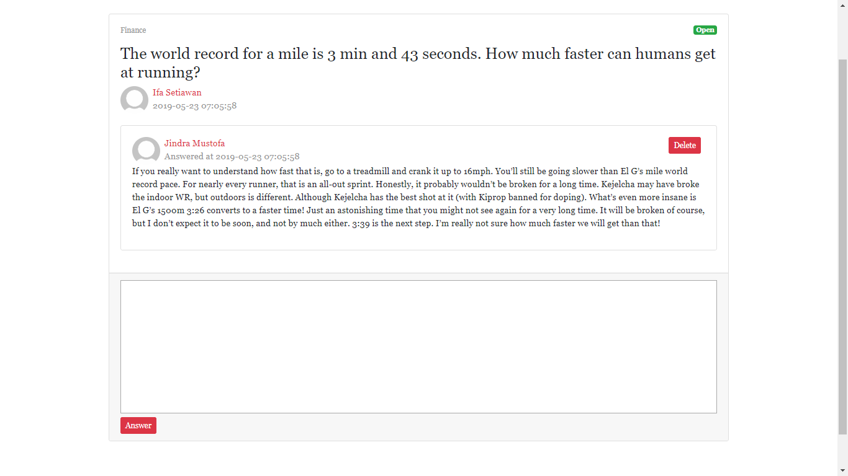
Figure 9. Answer Page (Viewing Another User Answer)

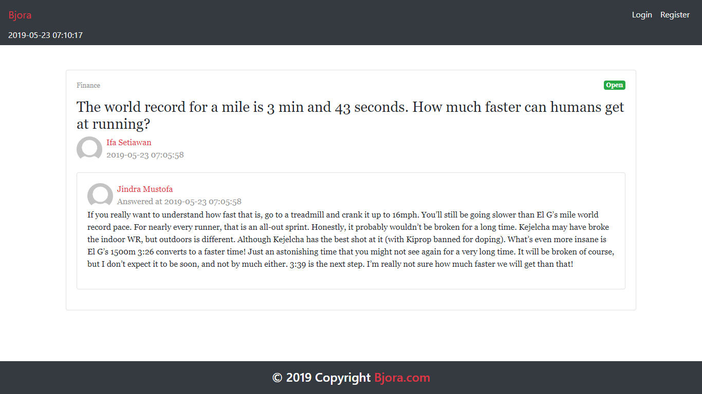
Figure 10. Answer Page (for Guest)

Profile Page
This page is accessible to member and admin. This page allows user to see their profile or another user’s profile.
There are some requirements on this page:
- If the user is viewing their own profile, validate that only Edit button is visible. If user clicks the Edit button, then redirect user to Edit Profile page
- If the user is viewing others user’s profile, validate that only Send Message form is visible. If user clicks the Send Message button, validate that the message field must be filled beforehand, and then send the corresponding message to the user
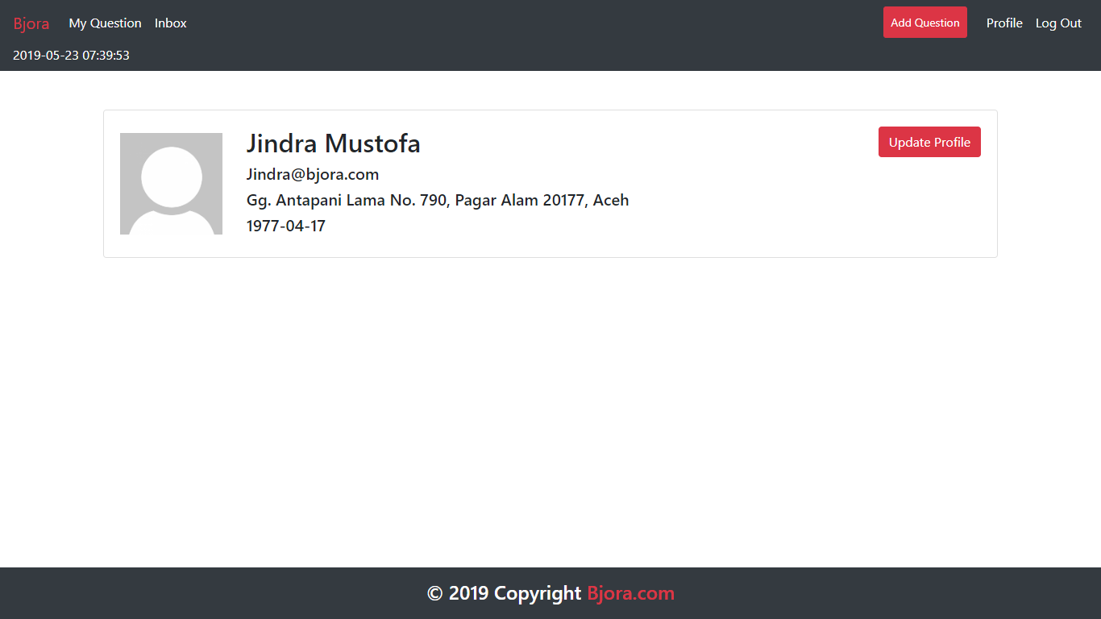
Figure 11. Profile Page (Opening Current Logged in User)
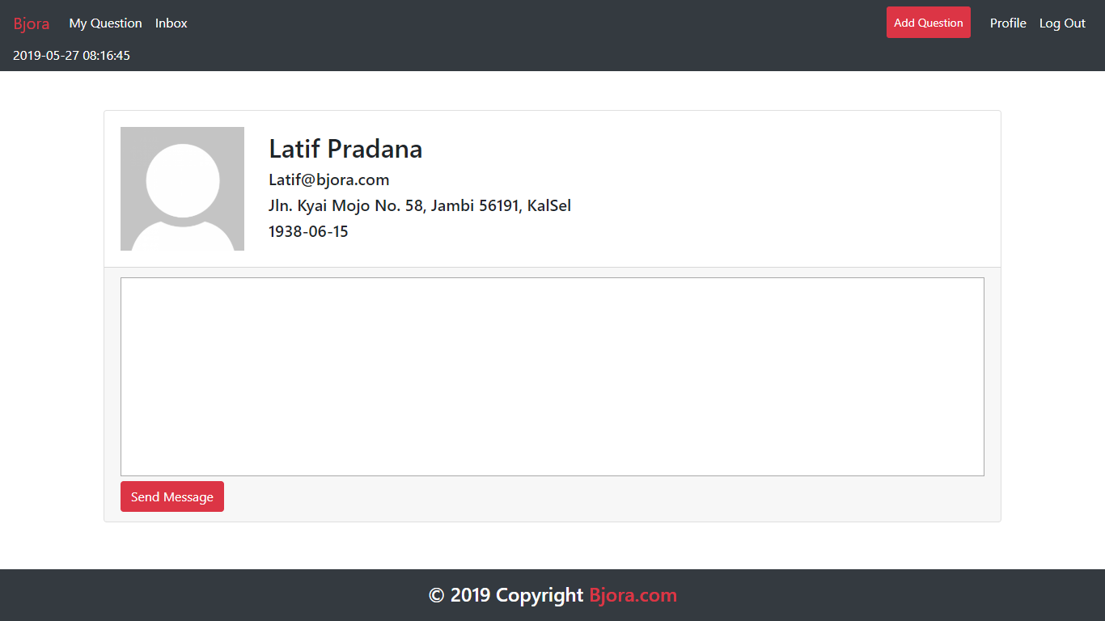
Figure 12. Profile Page (Viewing Another User Profile)

Inbox Page
This page is accessible to member and admin. This page allows user to view and delete messages they received. Display message information such as message’s content, message’s sender, and message’s creation date. In this page, all messages displayed using pagination with 10 messages each page. If user click Delete button, then delete the selected message.
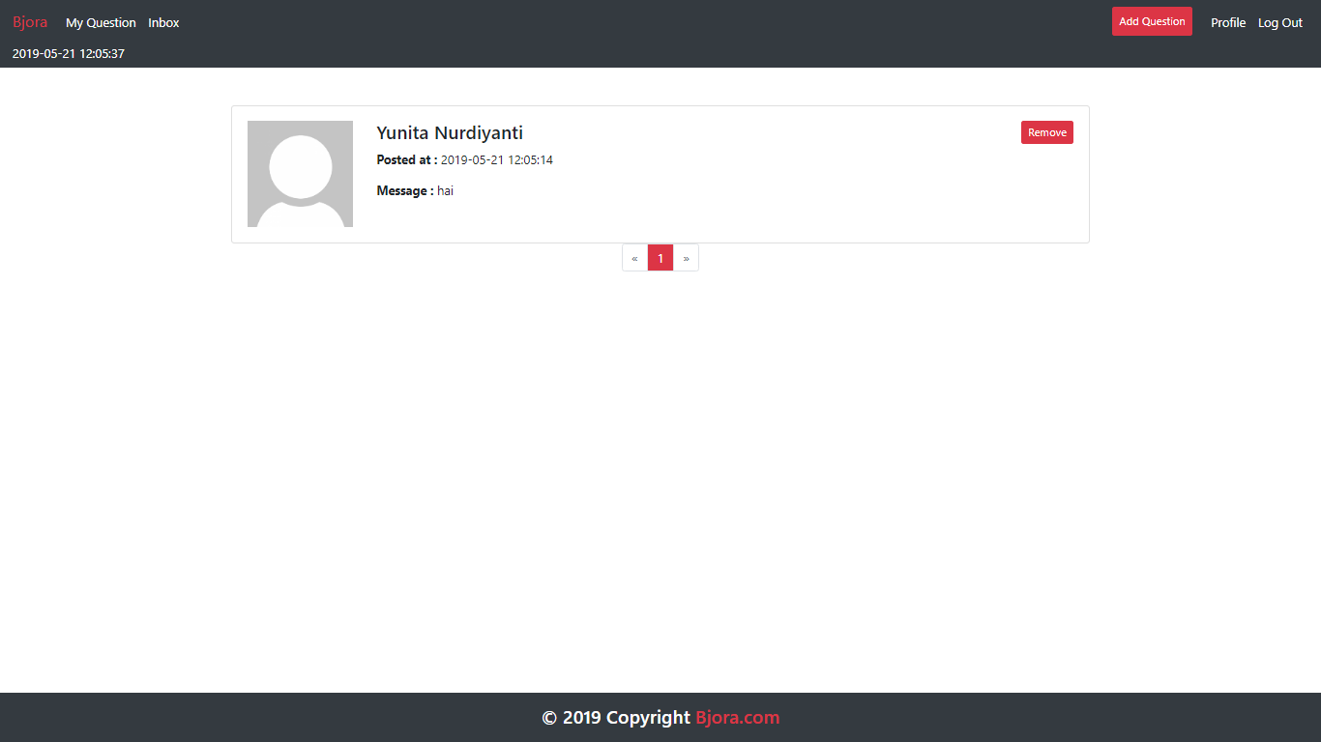
Figure 13. Inbox Page

My Question Page
This page is accessible to member and admin. This page is accessible by clicking My Question in navigation bar. This page shows all question that user has posted by using pagination with 10 questions per page and allows user to edit or close that question. Display question information such as question’s content and question’s status.
Each question in the lists have ‘Edit’ and ‘Delete’ buttons:
- If user click Edit button, redirect user to Update Question Page
- If user click Close button, change the selected question status to ‘Closed’. Validate ‘Close’ button only enabled for question that the status still ‘Open’
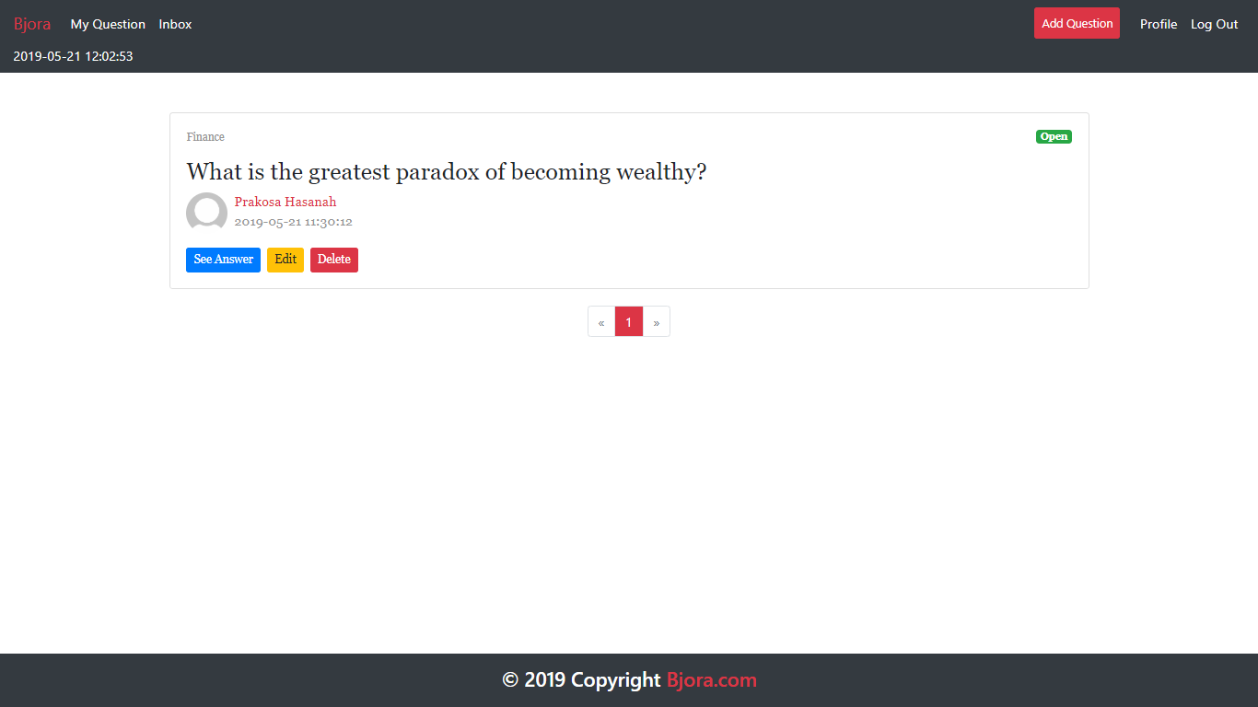
Figure 14. My Question Page

Master User Page
This page is accessible only to admin. This page shows all users using pagination with 10 users each page.
In this page, there are ‘Add New User’, ‘Edit’, and ‘Delete’ button:
- If user click Add New User button, redirect user to Add User Page
- If user click Edit button, redirect user to Update User Page
- If user click Delete button, delete selected user
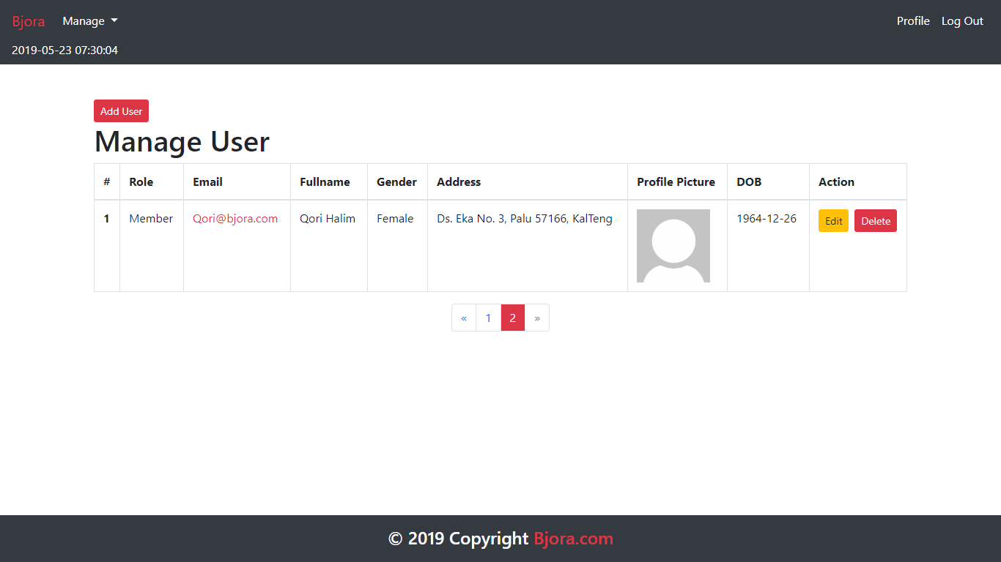
Figure 15. Master User Page

Add User Page
This page allows Admin to add new user. Display error message if user input incorrect user data. The following table shows existing fields in the Add User Page and the validation for each field:
Field | Information
Name | Must be filled with at most 100 characters
Role | Must be selected
Email | Must be filled with email and unique
Password | Must be filled with at least 6 characters and alphanumeric format
Confirm Password | Must be filled and same with password
Gender | Must be selected
Address | Must be filled
Profile Picture | Must be selected and must match one of the allowed MIME types (jpeg, png, jpg)
Birthday | Must be filled with date format

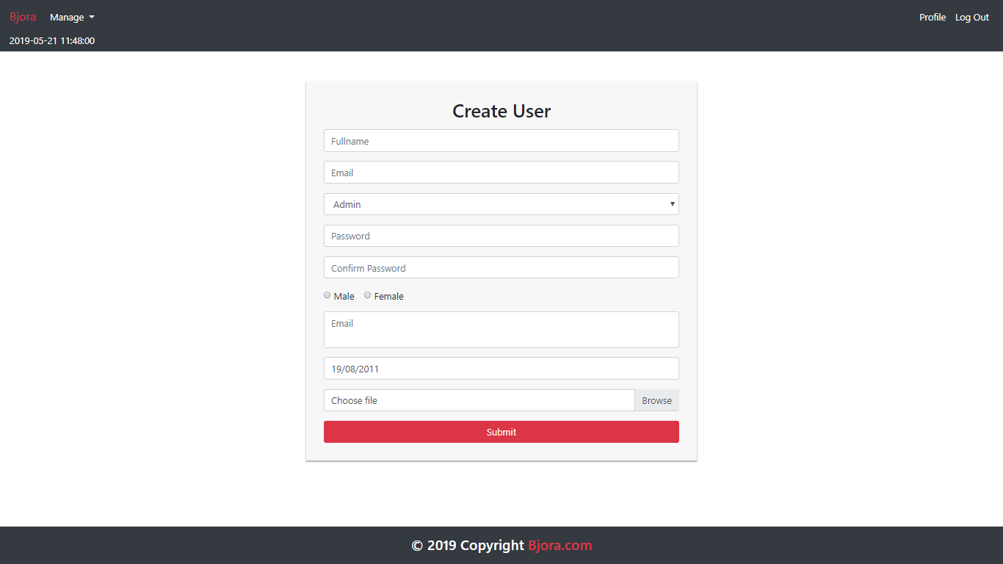
Figure 16. Add User Page

Edit Profile Page
This page allows user to update their profile data. Display error message if user input incorrect user data.
The following table shows existing fields in the Edit Profile Page and the validation for each field:
Field | Information
Name | Must be filled with at most 100 characters
Email | Must be filled with email and unique
Password | Must be filled with at least 6 characters and alphanumeric format
Confirm Password | Must be filled and same with password
Gender | Must be selected
Address | Must be filled
Profile Picture | Must be selected and must match one of the allowed MIME types (jpeg, png, jpg)
Birthday | Must be filled with date format

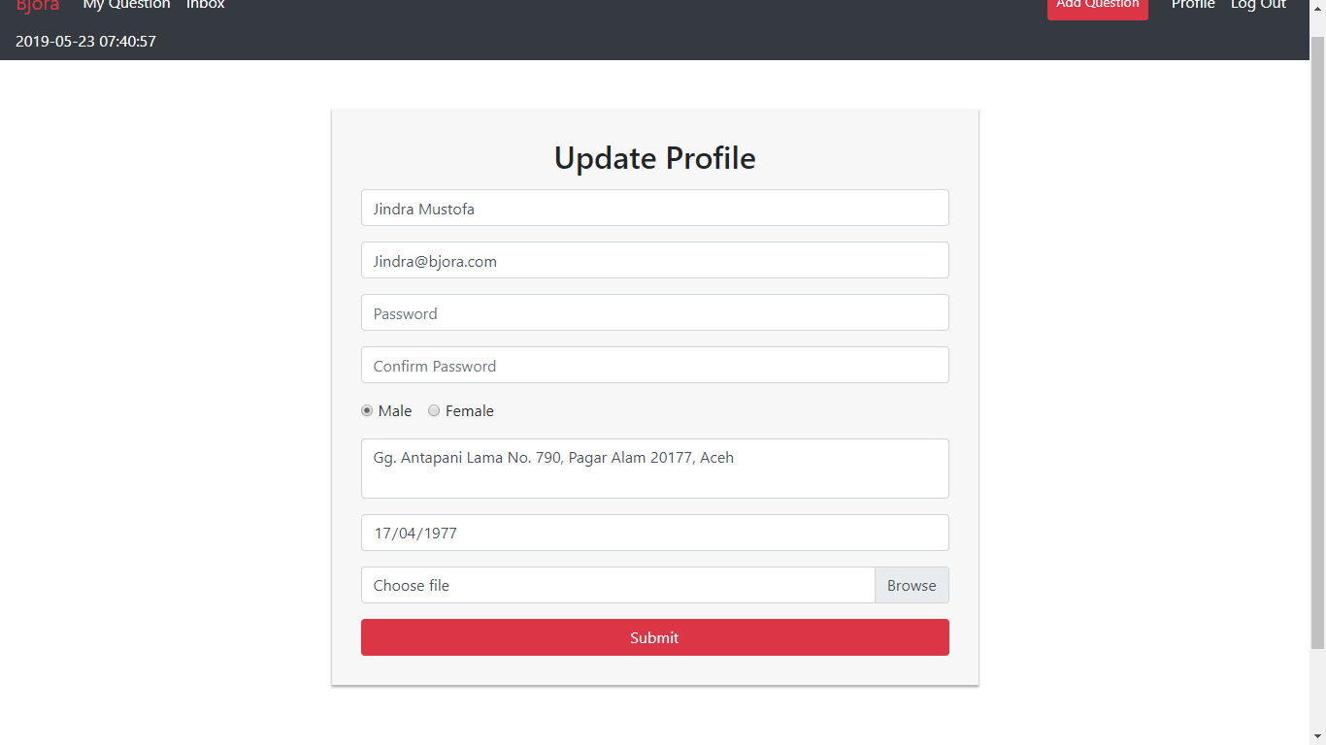
Figure 17. Edit Profile Page

Update User Page
This page allows Admin to update user data. Display an error message if user input incorrect data.
The following table shows existing fields in the Edit Profile Page and the validation for each field:
Field | Information
Name | Must be filled with at most 100 characters
Role | Must be selected
Email | Must be filled with email and unique
Password | Must be filled with at least 6 characters and alphanumeric format
Confirm Password | Must be filled and same with password
Gender | Must be selected
Address | Must be filled
Profile Picture | Must be selected and must match one of the allowed MIME types (jpeg, png, jpg)
Birthday | Must be filled with date format

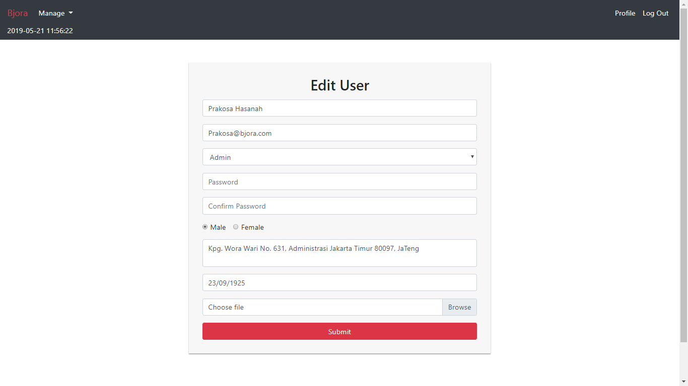
Figure 18. Update User Page

Master Question Page
This page is accessible only to admin. This page shows all questions using pagination with 10 threads each page.
In this page, there are ‘Delete’ button and ‘Close’ button:
- If user click ‘Delete’ button, delete the question
- If user click ‘Close’ button, update selected question status to ‘Closed’. Validate ‘Close’ button only enabled for question that the status still ‘Open’
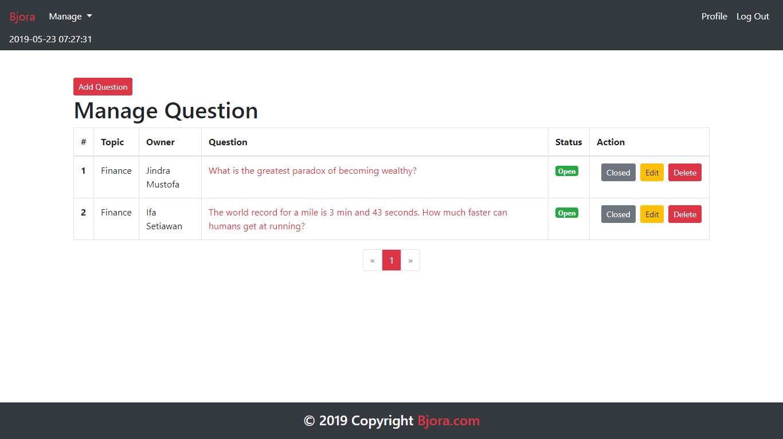
Figure 19. Master Thread Page

Master Topic Page
This page is accessible only to admin. This page allows Admin to manage all topics. In this page, there are ‘Add’, ‘Edit’, and ‘Delete’ button:
- If user click Add button, validate name field must be filled before user can add the topic. Display error message if user input incorrect topic data
- If user click Edit button, redirect user to Edit Topic Page
- If user click Delete button, delete the selected topic
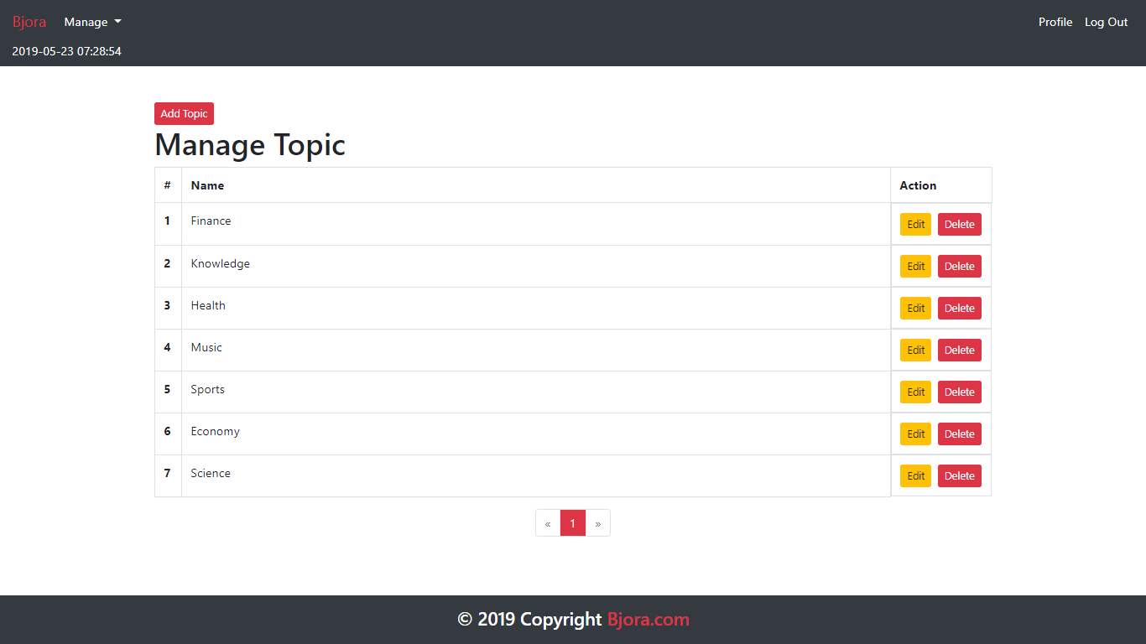
Figure 20. Master Category Page

Update Topic Page
This page allows user to update topic’s name. The name field must be filled before user click Update button. If the user clicks Update button, then update selected topic.
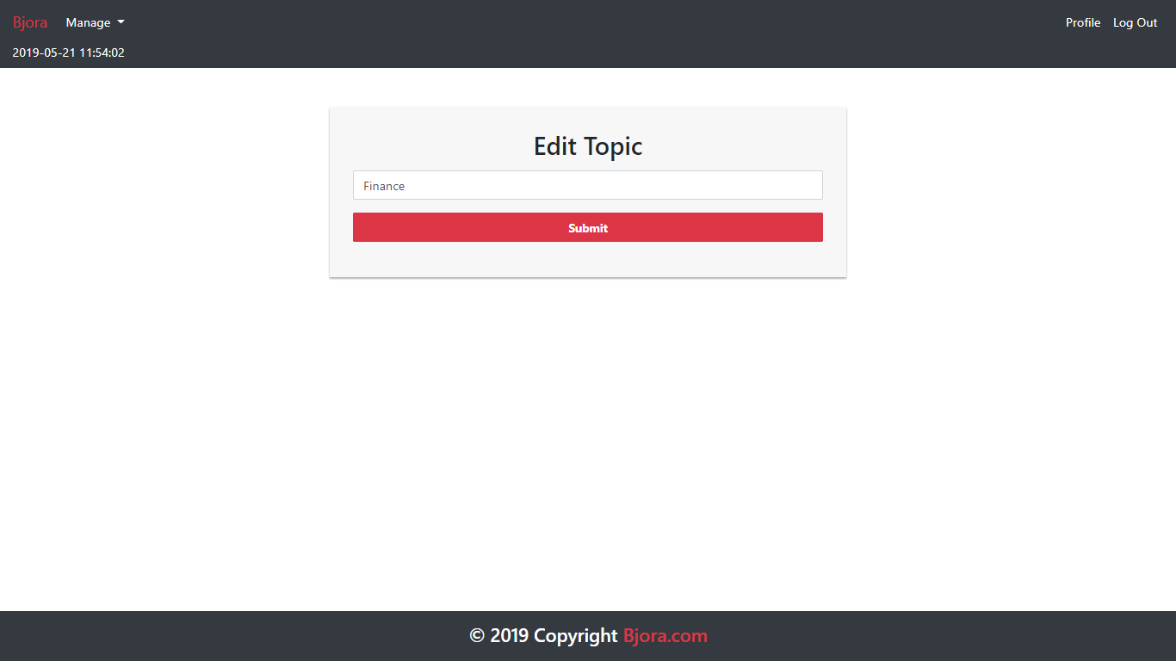
Figure 21. Edit Category Page
Here are the rules that you must follow to create your project:
- Use appropriate software for this subject based on Sistem Praktikum that can be downloaded from Binusmaya.
- Collect appropriate files for this subject based on Sistem Praktikum that can be downloaded from Binusmaya.
- Include the other files that can support your project, such as:
  - All files in your project
  - Other files (image, audio, video, etc.) used in your project
  - *.DOC file (documentation of your project) that contains all pages in your project, reference links of additional files (image, audio, video, etc.) used in your project, the description about how to use your application, etc.
- If there are some hidden creativities, please note them in the existing documentation because they can greatly affect your project score

Reference:
https://cresscap.com/dummy-profile-pic/

